Step by step of title paperwork – (Auction 52605 was used for this example.)

- Print out title paperwork received from affiliate.
- Search title/perm plate in MNDrive

Click on ‘Search vehicle Information’
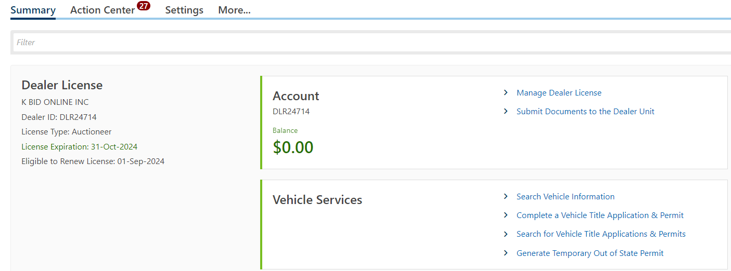

Check circle in front of ‘Title Number’, then enter title number on the line below search options, click search.
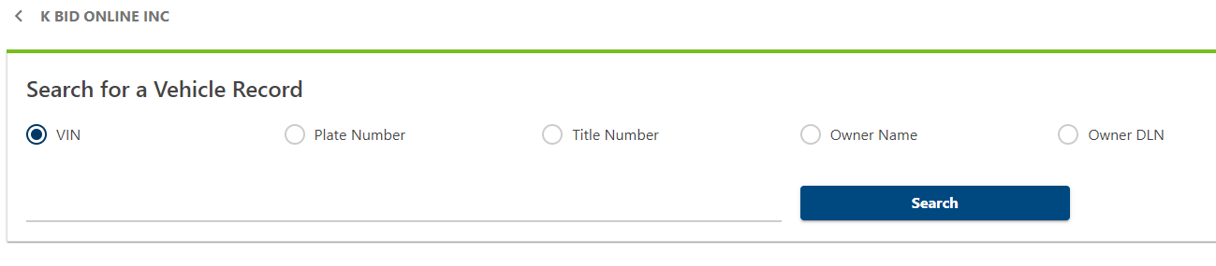
Results will show vehicle in system with that title number. In ‘Approved Business Reason for Search’ add explantion for running search.
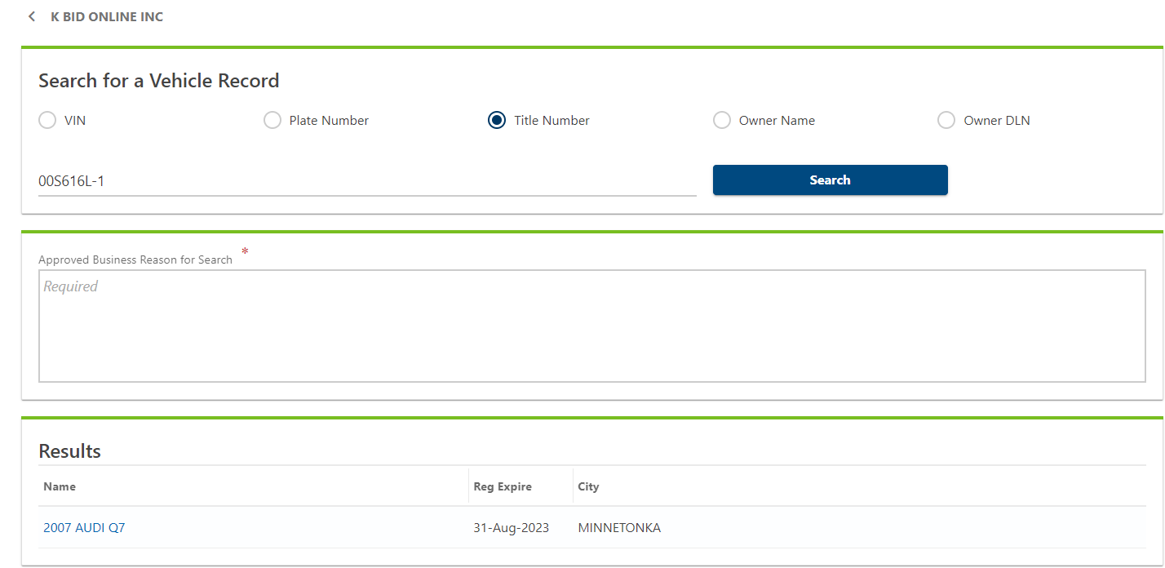
Once your explanation has been entered, click on the linked name of vehicle to get the results.
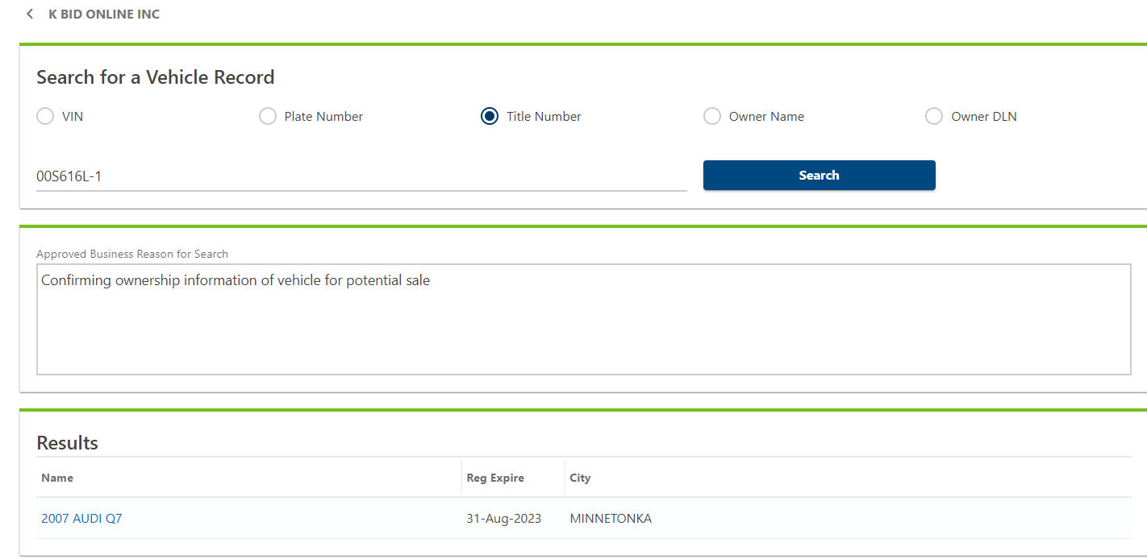

Review results before printing. ***Additional information will sometimes show on this screen that does not show in printed version.*** Click ‘Print Results’.
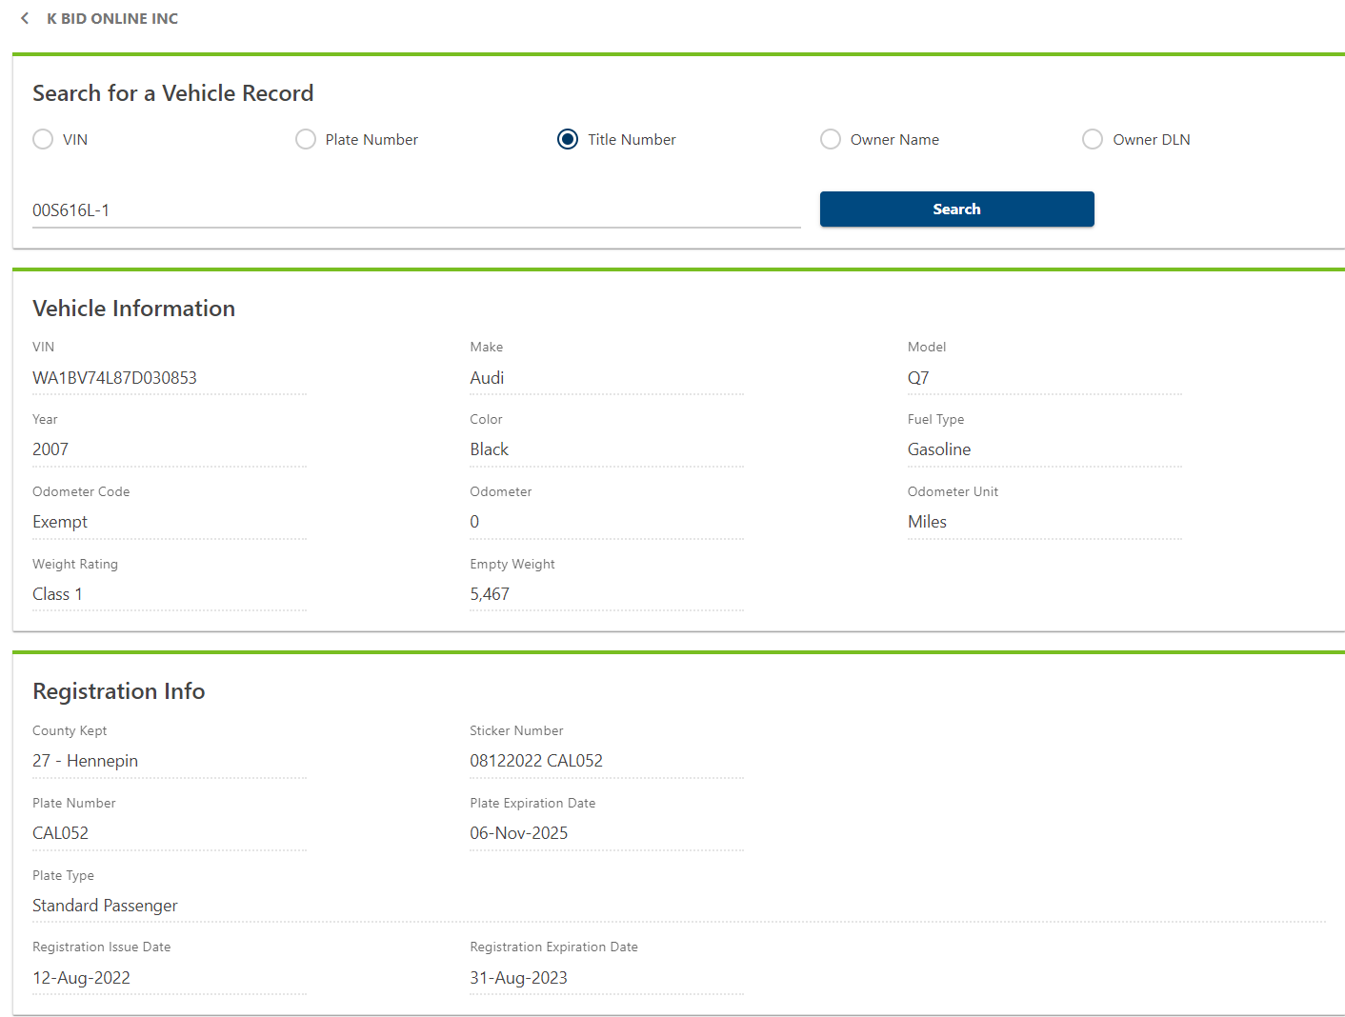
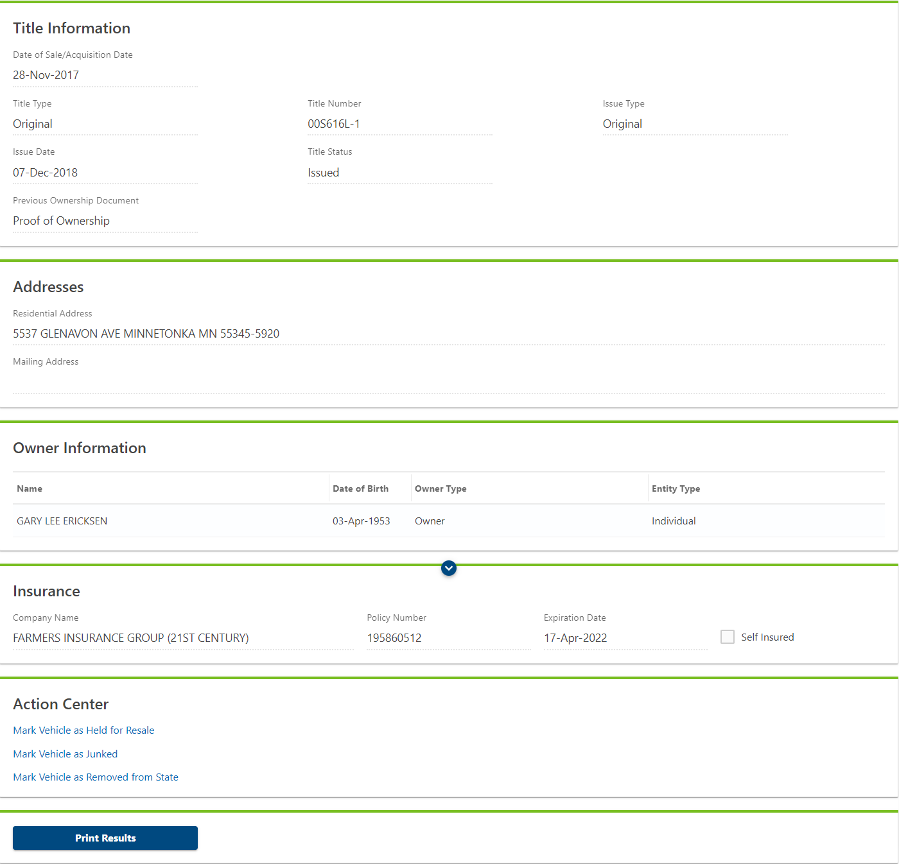
Once printed, staple to the back of the title paperwork with the information facing out.
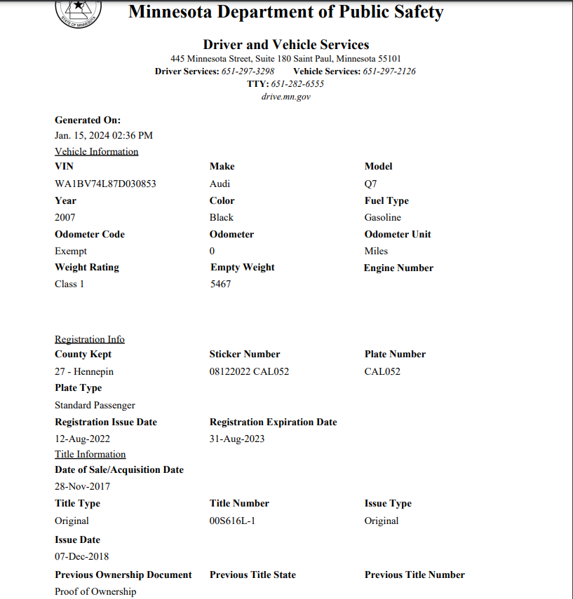
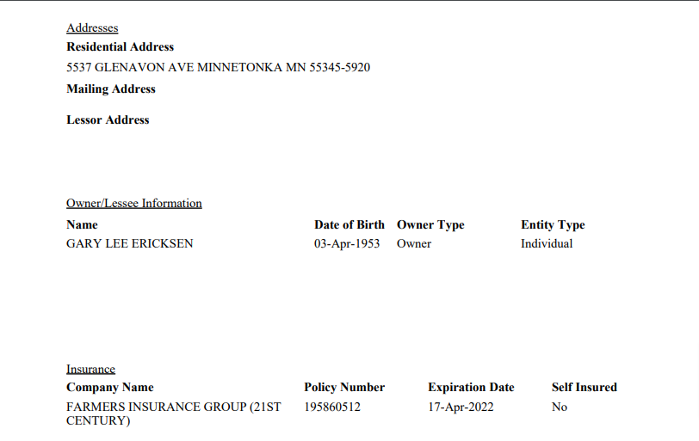

- Complete auction folder
- Add to ‘Titles’ spreadsheet
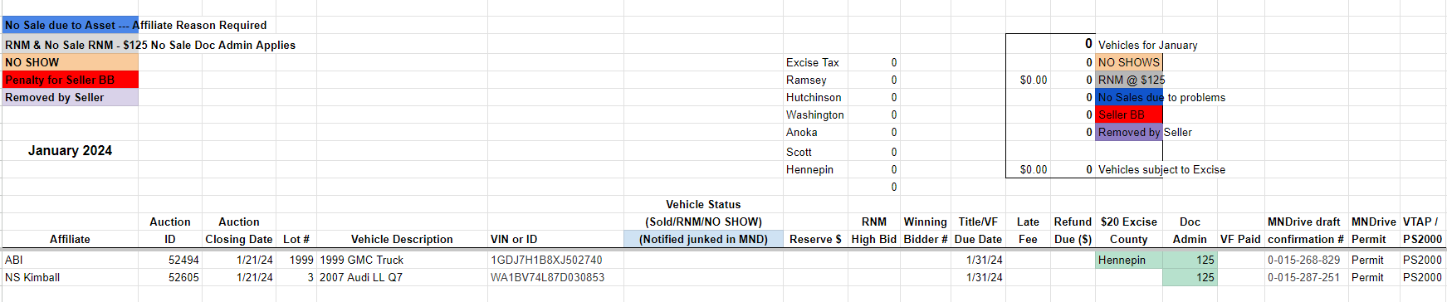

- Create draft in MNDrive

Click ‘Complete a Vehicle Title Application & Permit
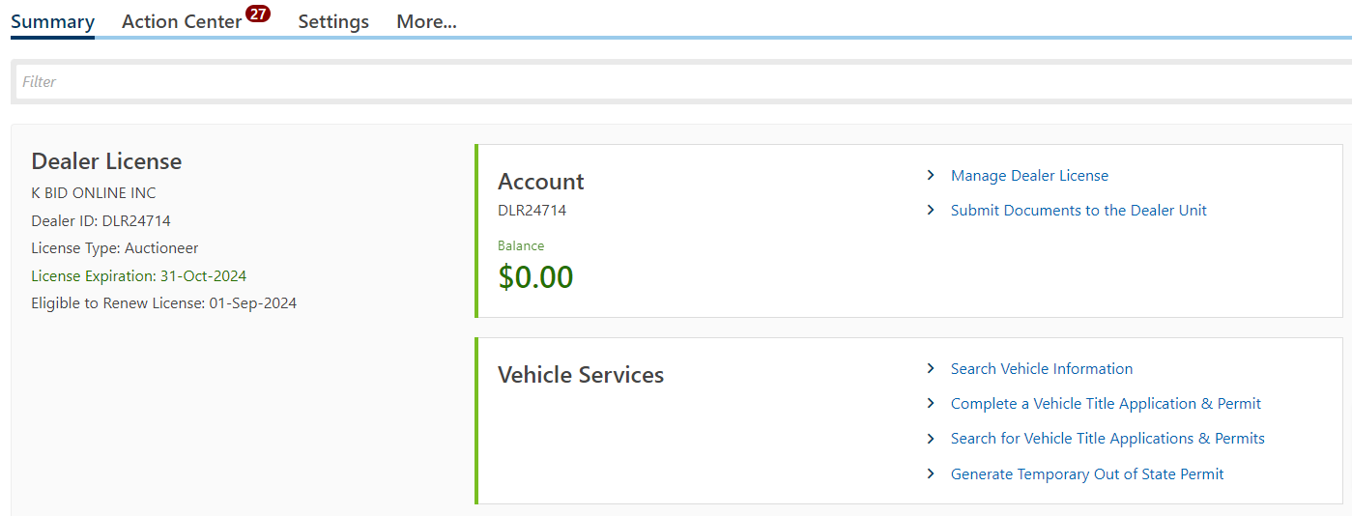
Enter VIN# on both lines, then click next
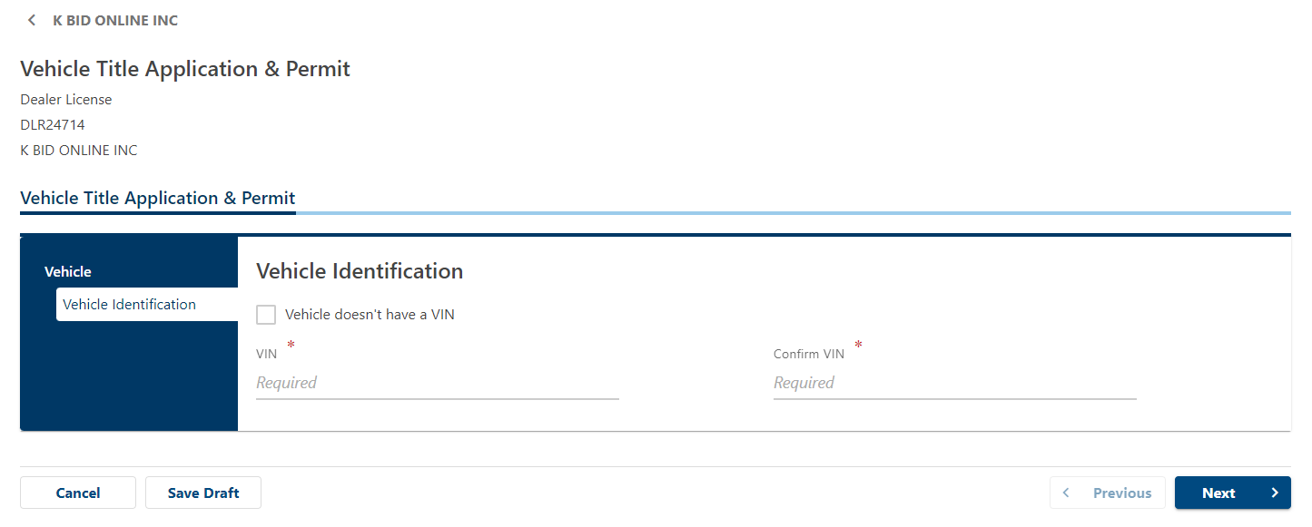
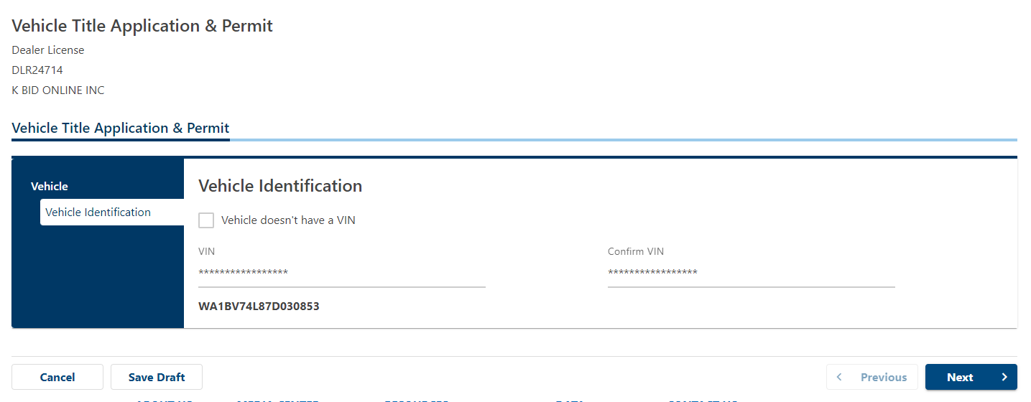
Note fields that are asterisked. These fields are required to move to the next page.
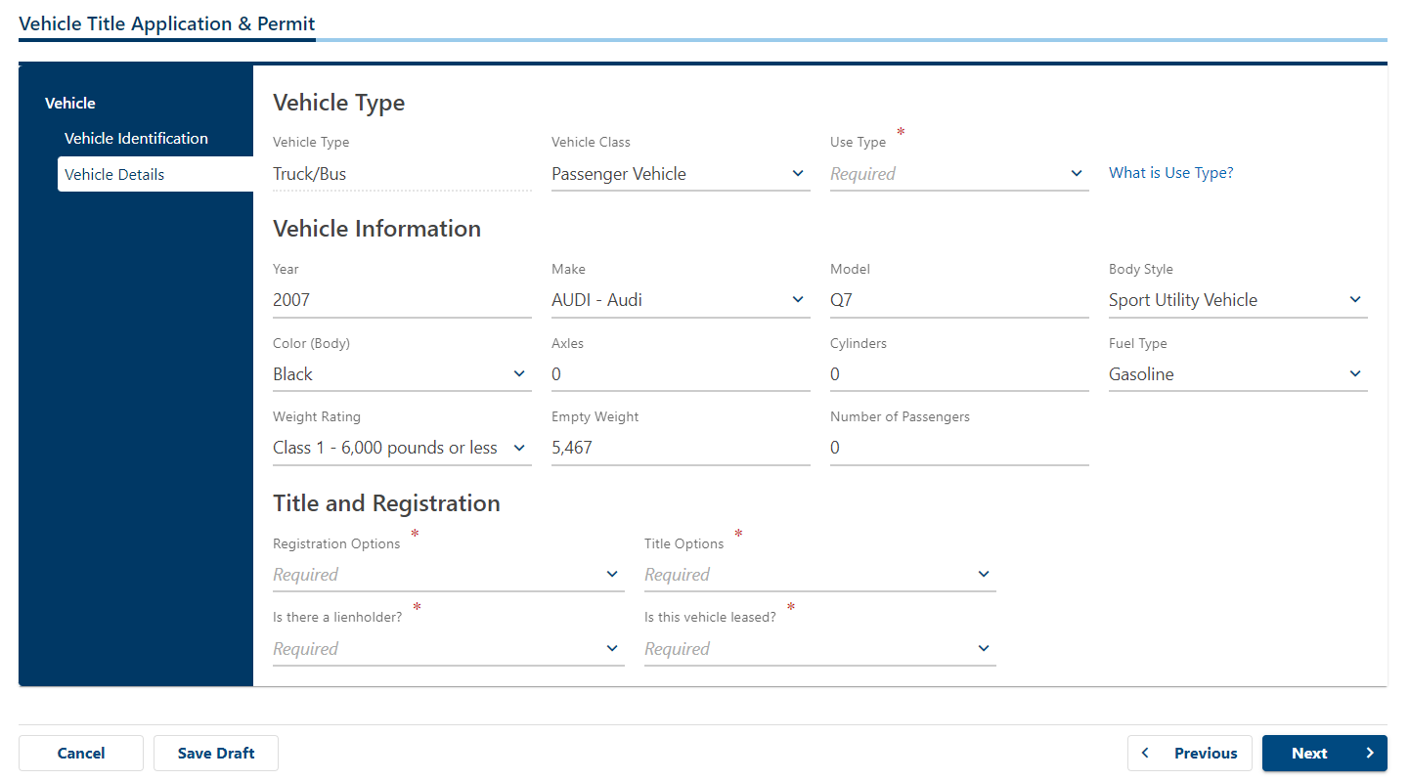

For a standard general use passenger vehicle, choose ‘Personal Use’ under Use Type.
If plates are still good, choose ‘Keep Existing Plates’ under Registration Options. If new plates are needed, choose 'New/Change Plate’.
Title Options will always be ‘Original’
Is there a lienholder? This is typically ‘No’. If a lien is being added to the title, choose ‘Yes’. This will have a page come up to add lien holder information.
Is this vehicle leased? Will always be ‘No’.
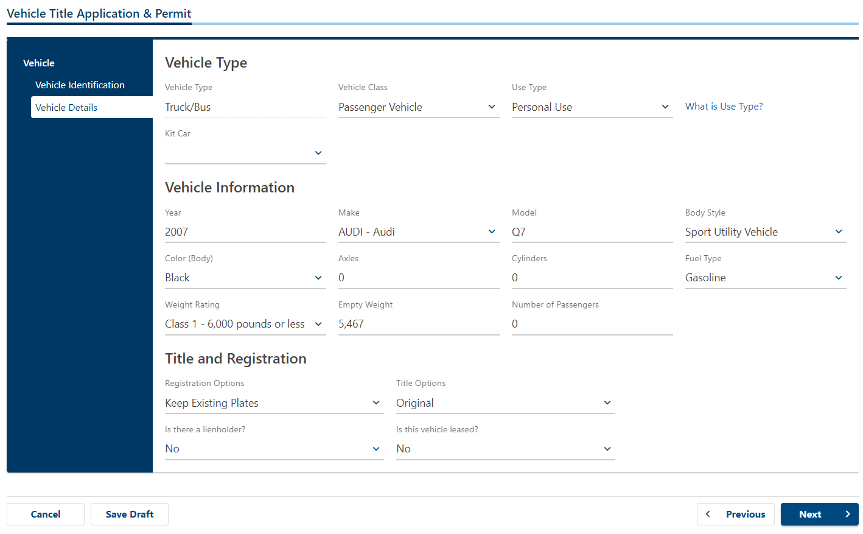
Enter the title number listed on the title copy you received from the affiliate. Choose any insurance company and future date for insurance. Enter any letter for policy number.
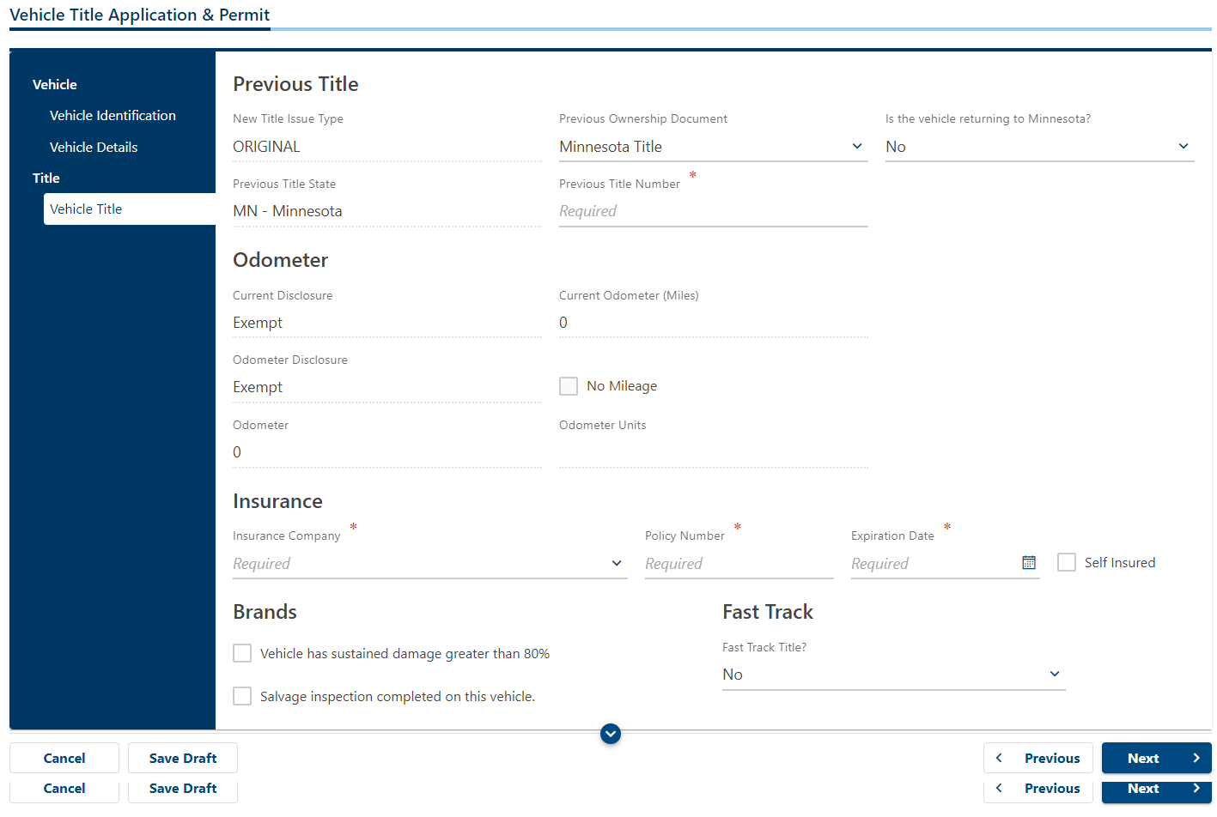

Example:
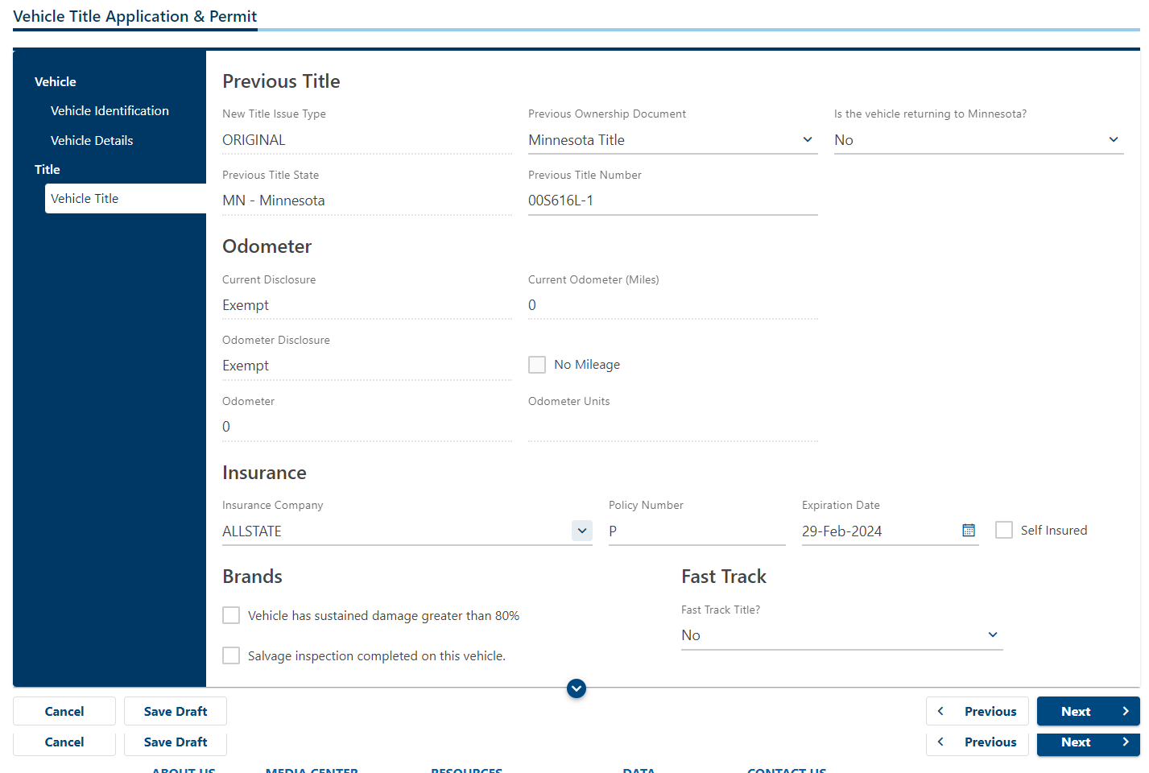
Enter information in ‘MN Credential Number, Date of Birth, First Name, Middle Name and Last Name. Enter ‘No’ for E-Renewal Notice?
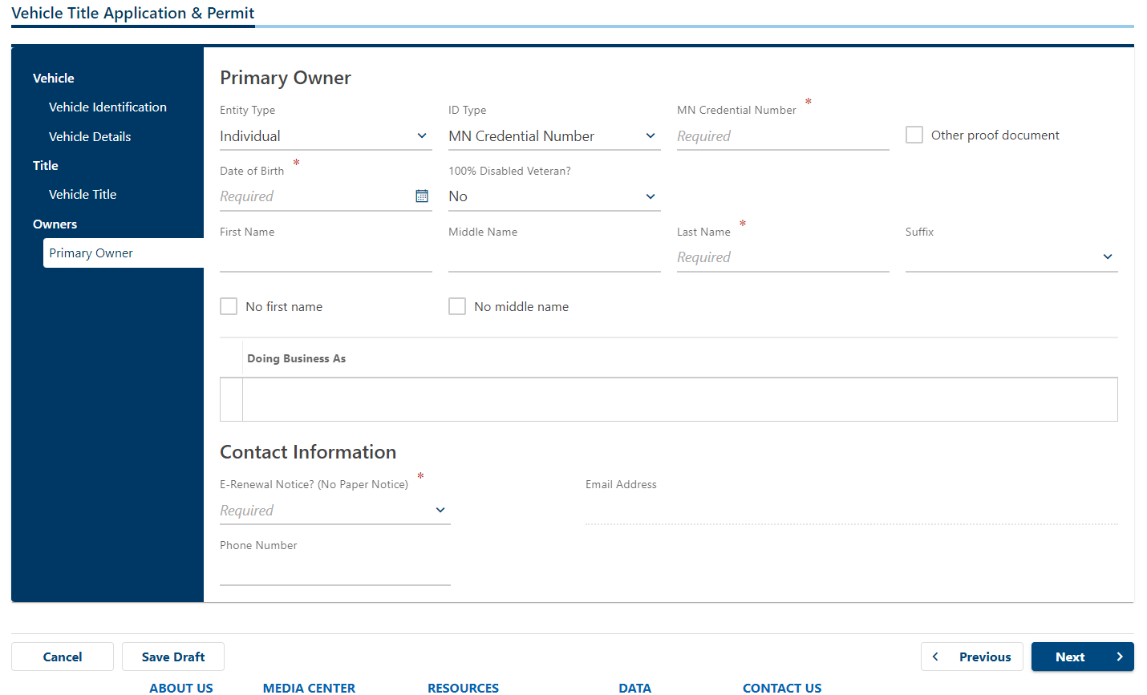

Example:
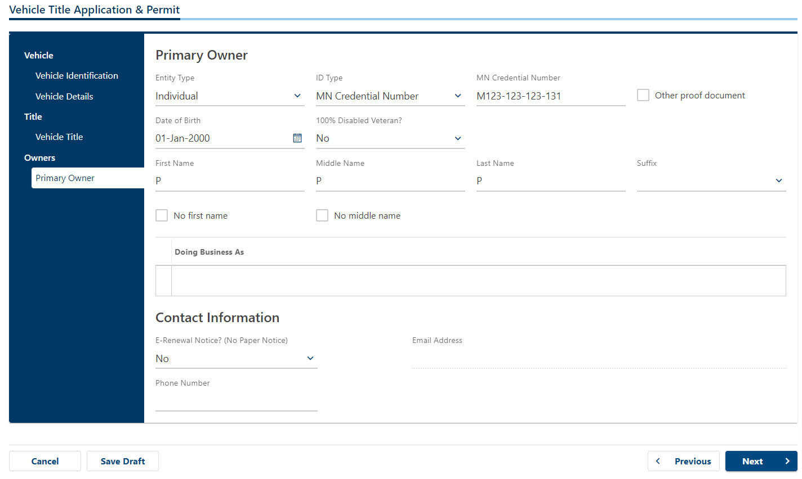

Enter K-BID address as placeholder for address.
Enter ‘No’ for Is the mailing address different than the residential address?
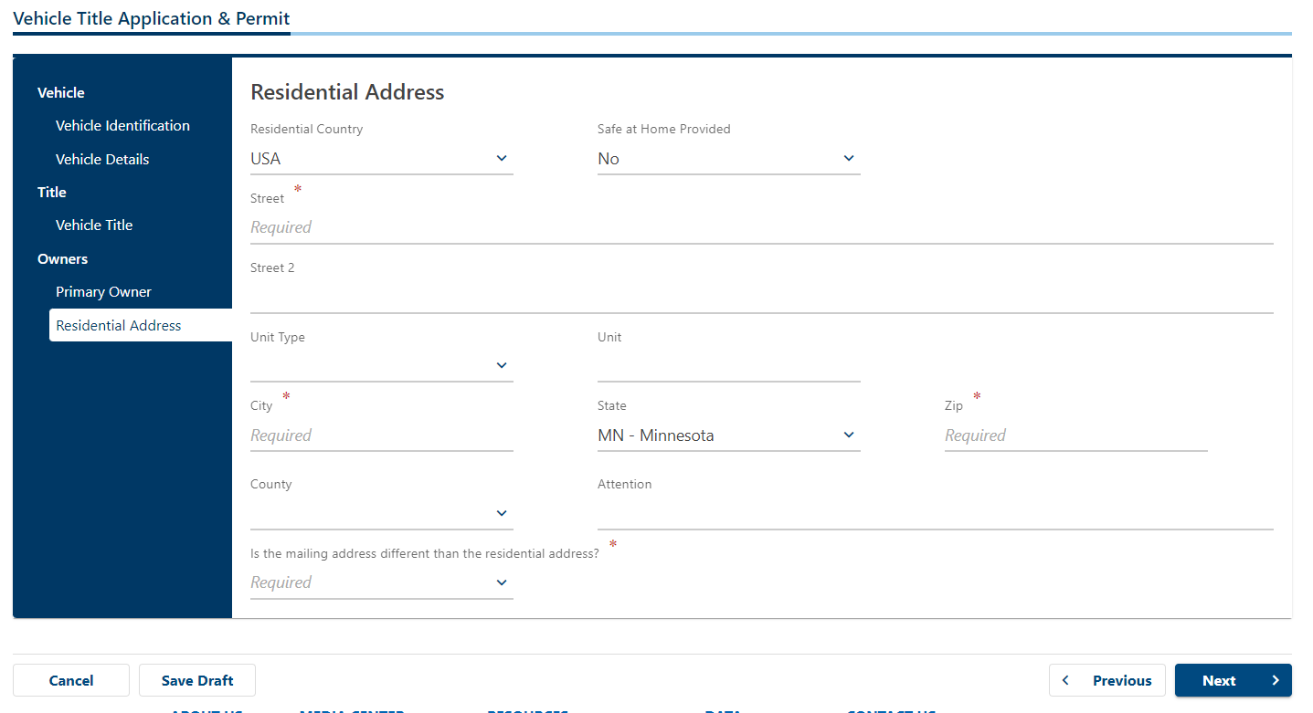

Example:
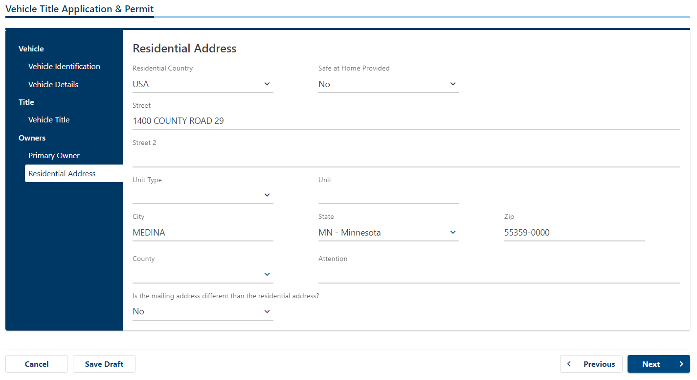

Click next for the next two screens.
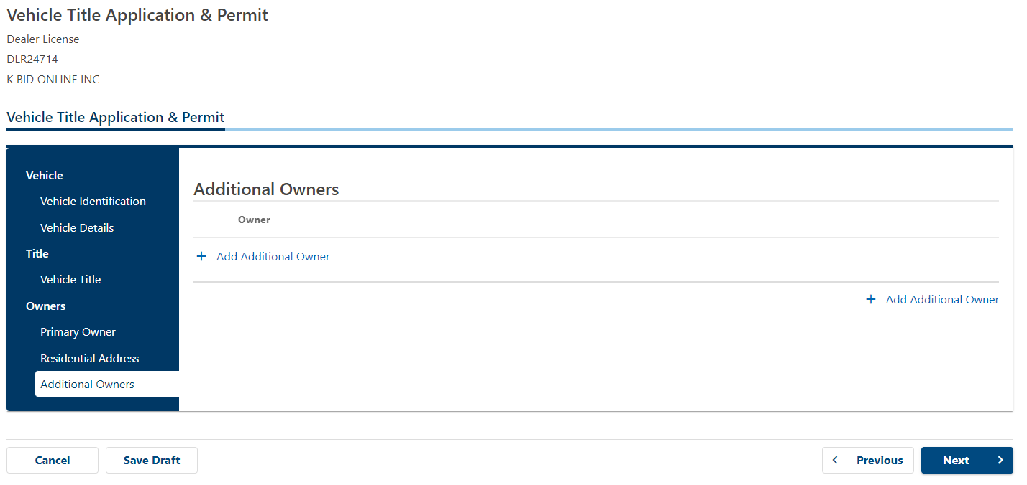
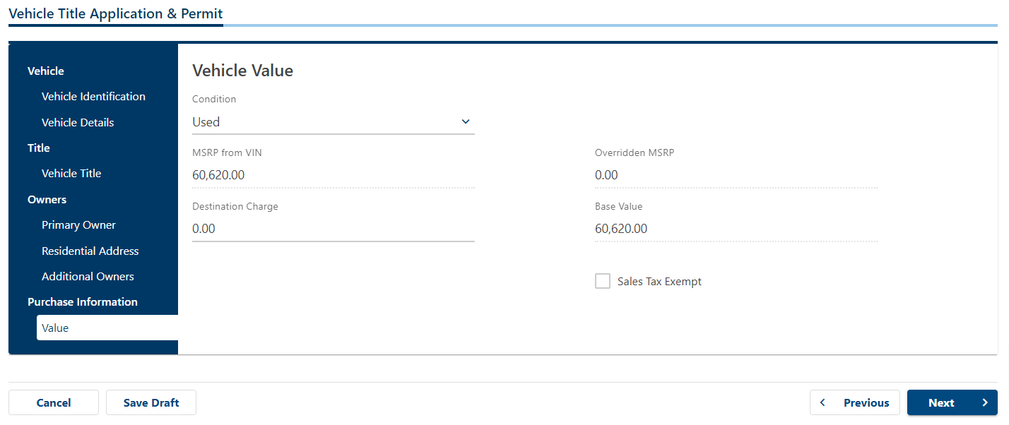
Enter current date for ‘Acquisition Date’, Enter single number (i.e. 5) for ‘Purchase Price’, Choose ‘Yes’ for ‘Consignment’, then check box for ‘Private Party’.
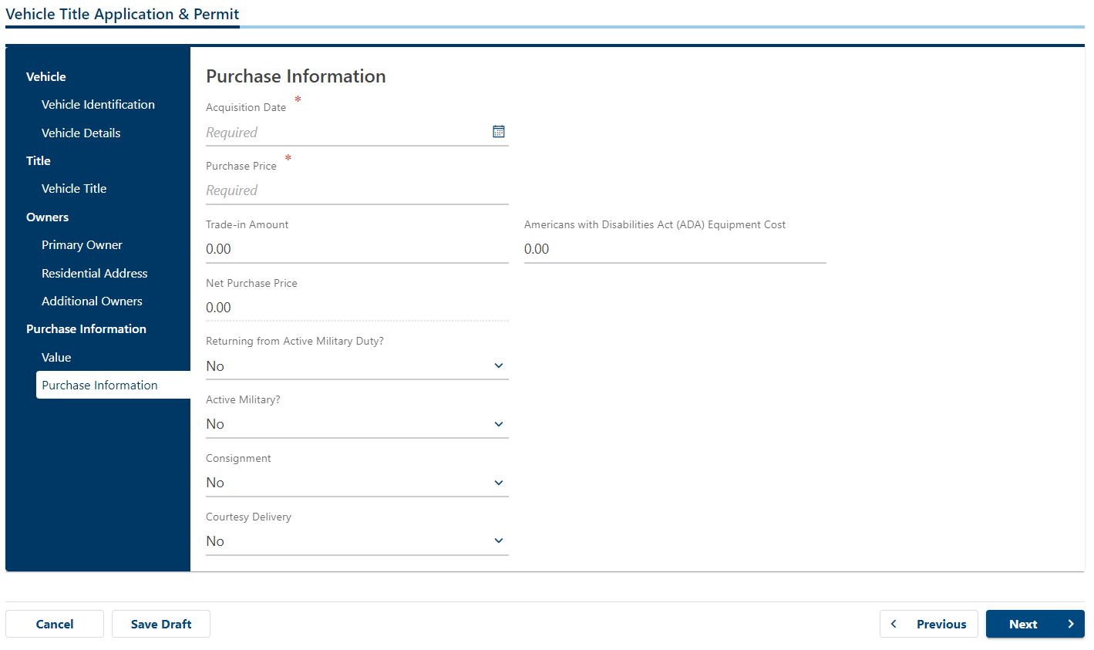

Example:
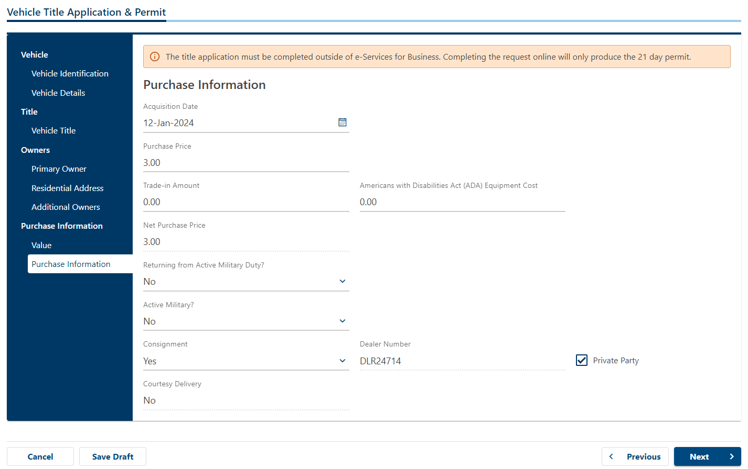

Click Next
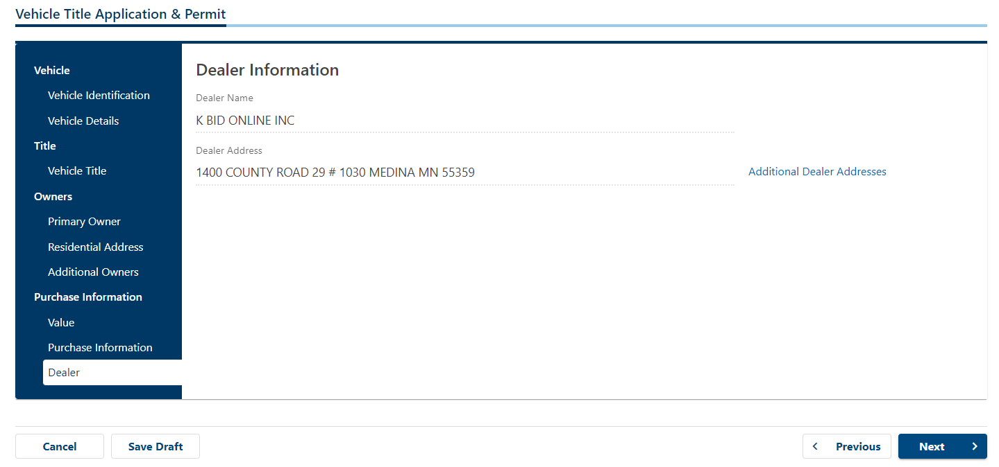

Enter ‘Hennepin’ for MN County Vehicle Kept
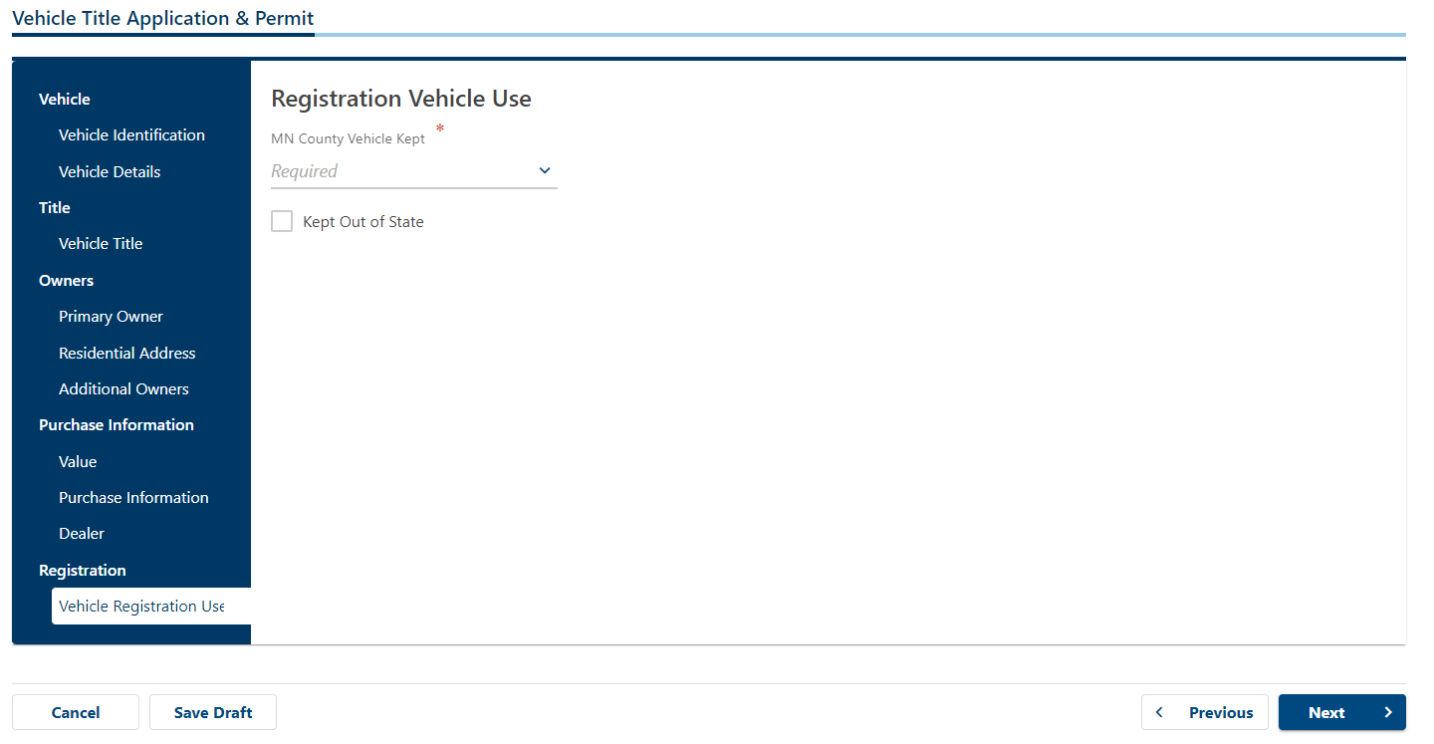

Example:
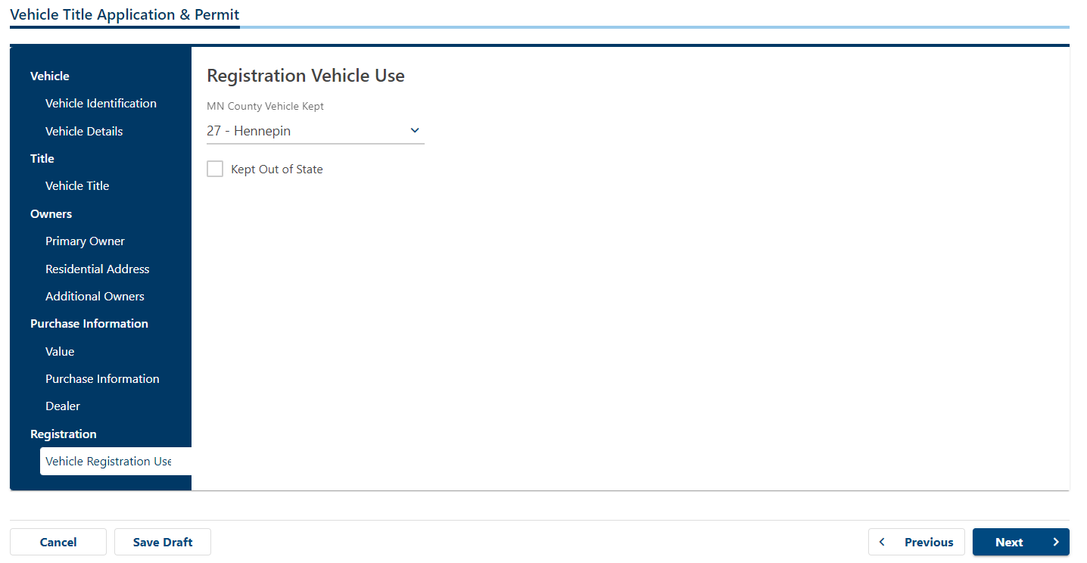

If permit is needed, choose ‘Yes’ for Print 21-day Permit? If plates/registration is current, choose 'No’.
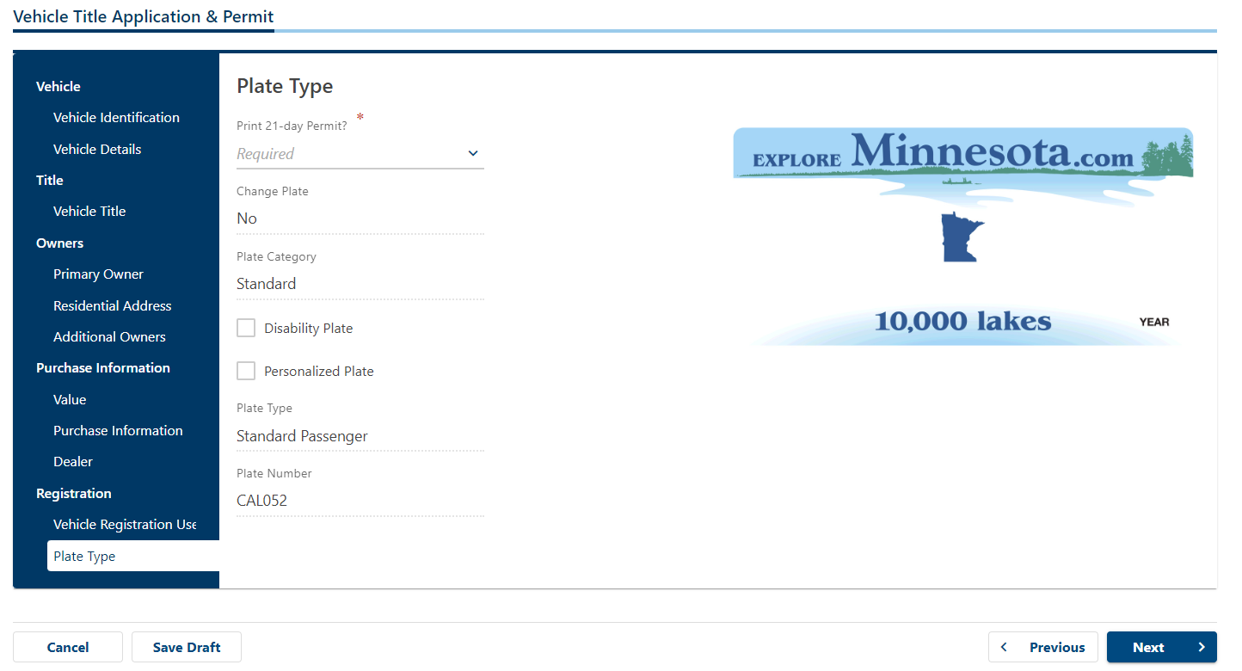

Example:
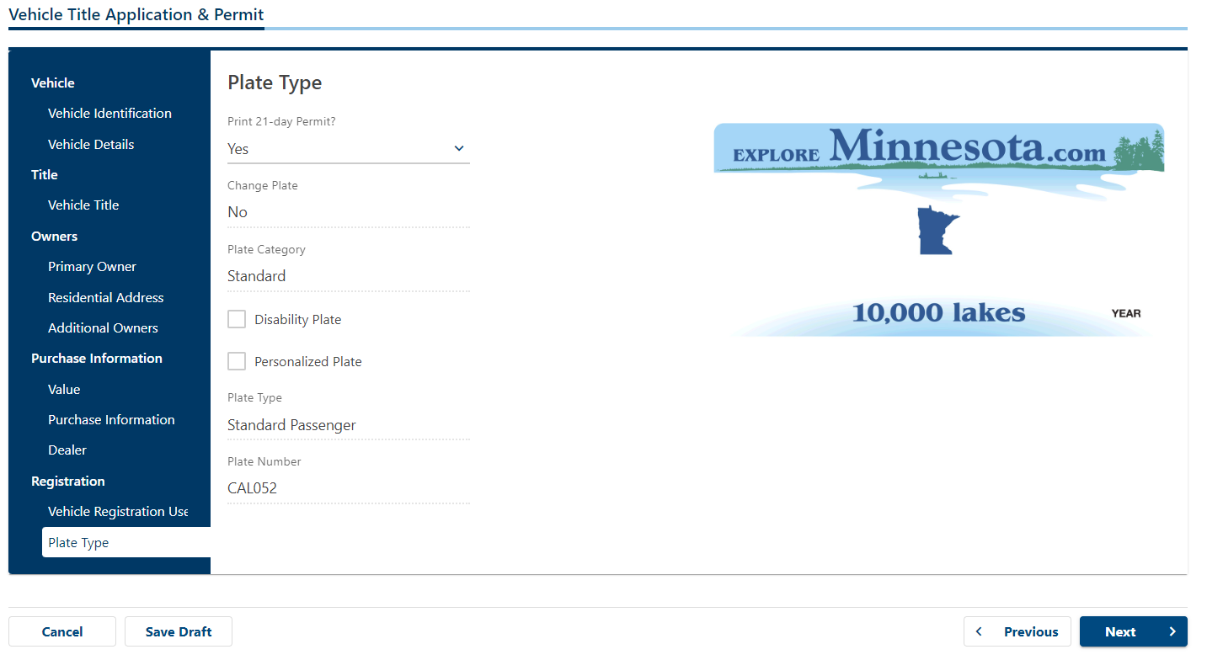

If registration is needed, choose 'Yes’ for Renew Registration?
Registration Quantity will typically be 1 (year). ***If this were a commercial vehicle/trailer and February is approaching, you would enter 2.***
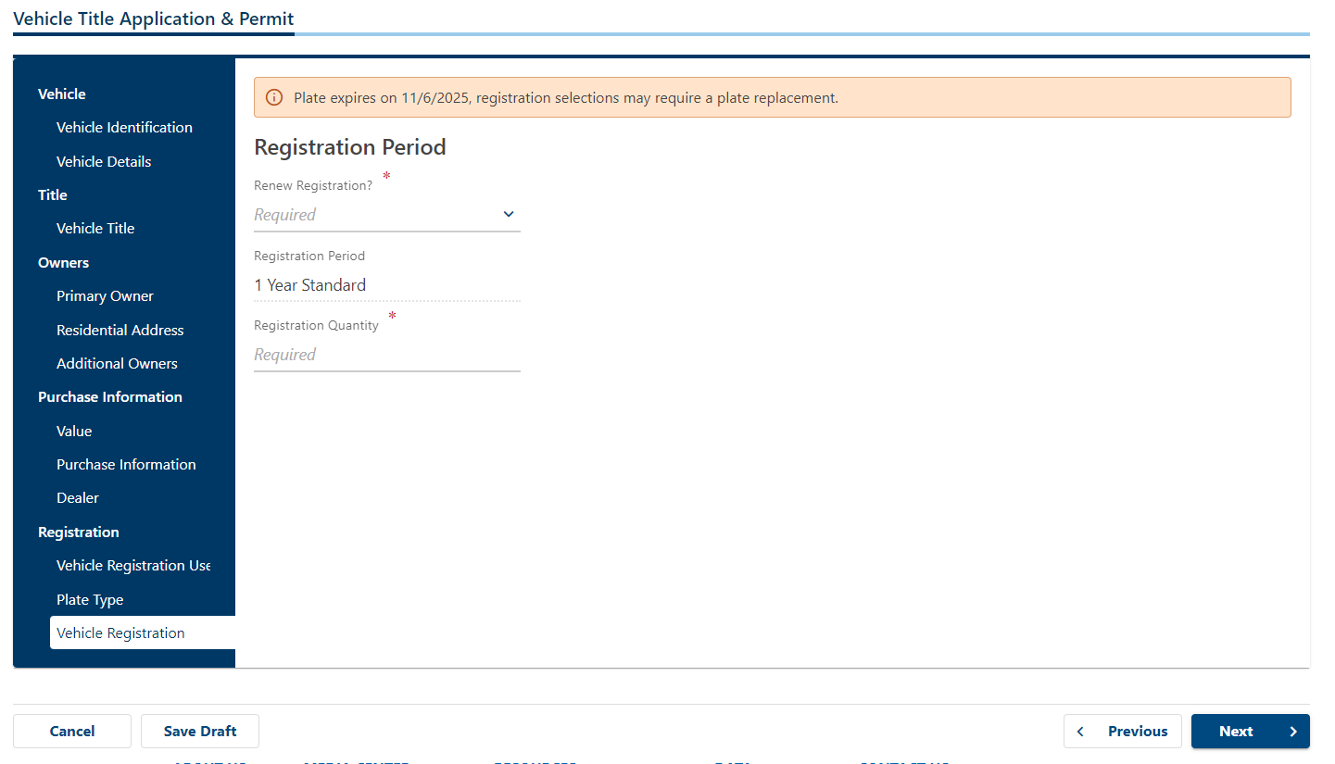

Example:
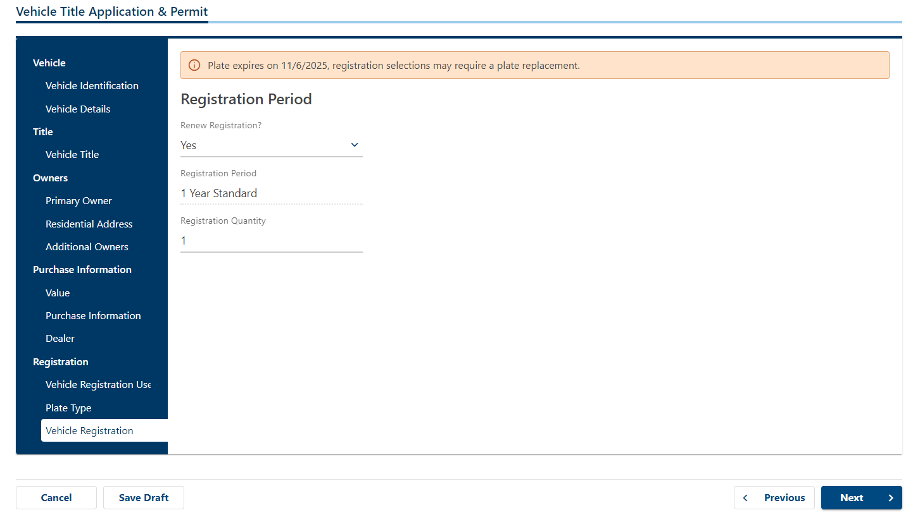

This page indicates paperwork needed for title transfer. Click next
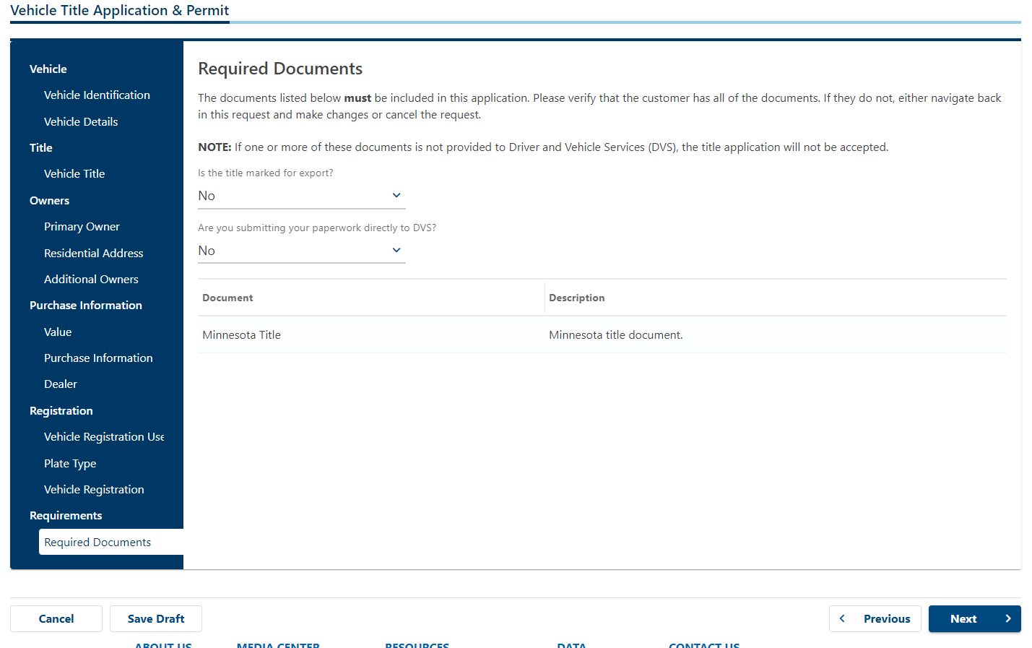

This page lists the fees required to transfer title paperwork. Click ‘Save Draft’
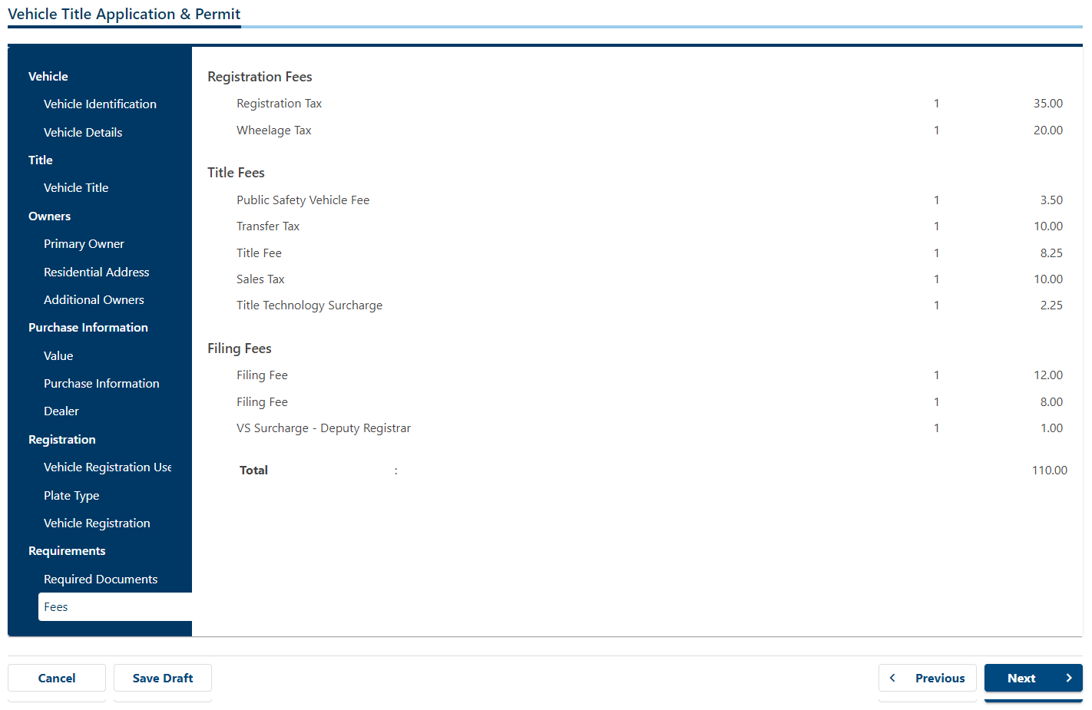

Highlight and copy Confirmation number to add to Title spreadsheet. Click ‘Finish Later’
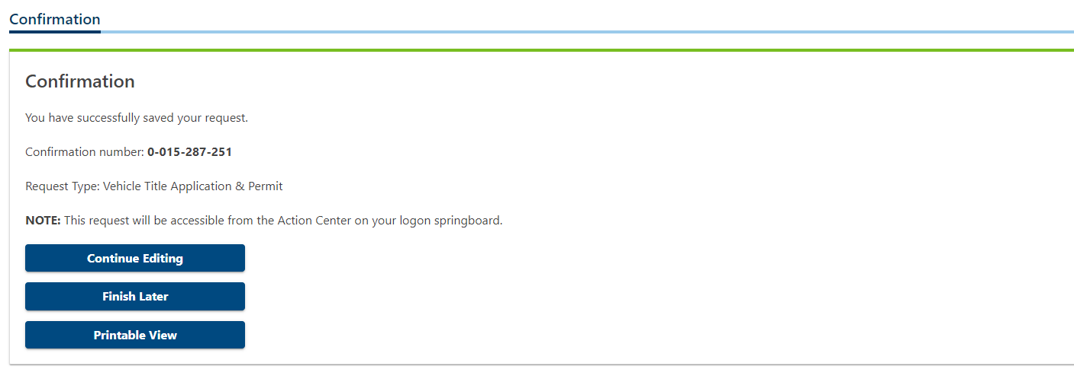

- Create folder for auction under ‘Titles’ using auction number as name

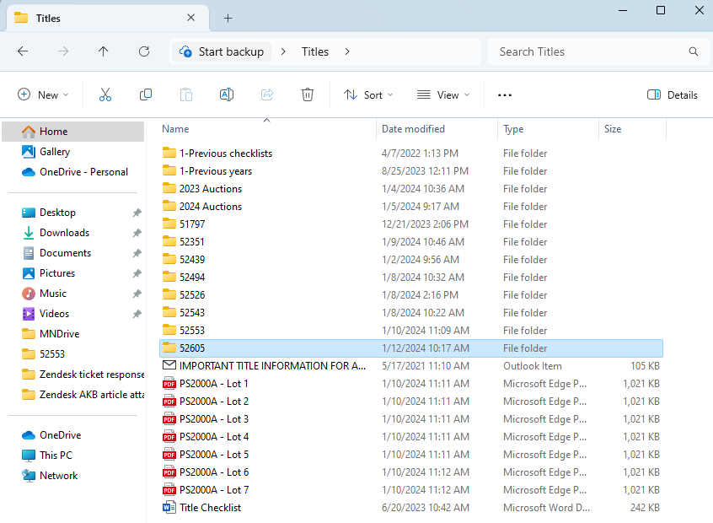

- Add copies of the Email template, PS2000 (for each lot) and Title checklist to folder

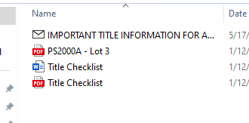

- Add information to Title checklist for auction/lots. For each lot, remove information that is not needed for title transfer. This will leave only the required documents necessary for transferring ownership to the buyer. Save document and create PDF copy for emailing.

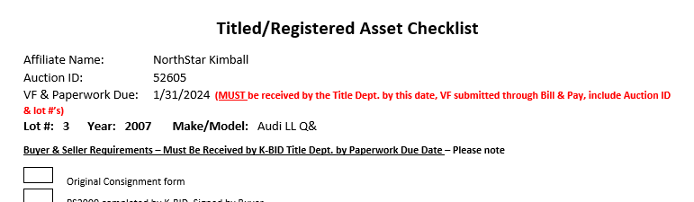

- Review information listed on lot description and compare to consignment form/title copy. If there is a discrepancy, email the affiliate to add/update the information listed.
- Add notes regarding fees & registration form to bottom of the lot description
- Check boxes for ‘No Online Payment’ & ‘No Shipping’. Uncheck box for ‘Is Taxable’
- Add fees (they should match the amounts listed in the draft created in MNDrive) & Save
- Send ‘Ok to publish’ email with customized checklists attached to the affiliate
- Start PS2000 for each lot, saving draft
- Place auction folder in pile by auction close date

After auction has closed:

- Check for completed registration forms, by clicking on ‘View All Bidder Supplied Field Info’ at the bottom of the invoice list
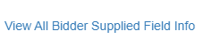
- Scroll to lot with vehicle
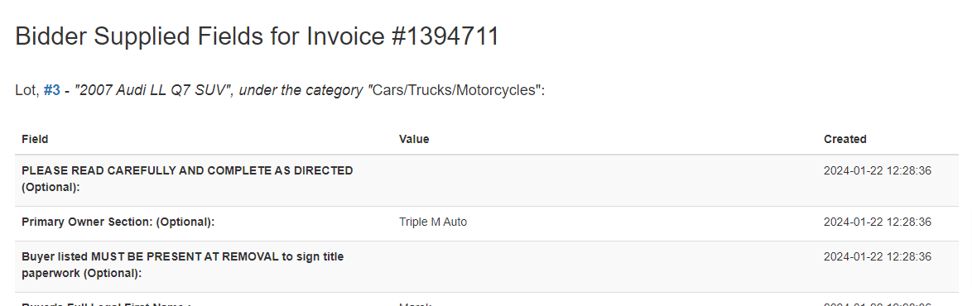
- Click on Awesome Screen Recorder & Screenshot icon. Highlight registration form, taking screenshot printing to copy information. (Only Field and Value columns need to be highlighted) Paste on blank Word doc to print information out on one sheet. Repeat this for each lot selling asset that has completed information.
- Review the invoices, making adjustments. Print out invoice copy once done. **Uncheck ‘No Online Payment’ box when registration form has been completed.
- Staple invoice to top of lot paperwork, paperclip registration information to back of paperwork
- Update PS2000 and draft in MNDrive for all transactions. (DMV uses confirmation # to open transaction in MNDrive to complete transaction.)
- Create email draft for removal morning, attaching updated PS2000

Removal morning:

- Update date in MNDrive, submitting draft. Print out confirmation #. Download permit saving pdf with confirmation number as the name. Attach permit pdf copy to email draft. Move permit pdf to auction folder
- Send out emails for all lots with completed PS2000 and permit (if applicable). Each lot will be emailed separately with the subject line noting the auction number, lot number and documents being sent. (i.e.: ‘Auction 52605 Lot 3 PS2000 & Permit’ )
- Let affiliate know which lots are still missing registration information, so they can follow up on them and advise once ready
- Once emails for all lots have been sent to affiliate, place auction folder in tray to hold for signed paperwork & vehicle fees from affiliate

Paperwork to DMV:

- When title paperwork has been received from the affiliate, prep it to take to the DMV. Title and PS2000 should be dated. A copy of the PS2000 should be made. Place printed confirmation # page, PS2000 original, PS2000 copy, title, registration copy, driver's license copy and invoice copy (facing back) in sheet protector, then blue folder to take to the DMV.
- Get check from Becky
- Drop folder off at DMV
- Pick up folder from DMV once ready
- Give payment summary to Becky
- Pull out transaction summary for lot from DMV. (If none is provided, make copy of PS2000 to mail) Check transaction amount to check for differences in case refund is needed. Mail out to buyer.

